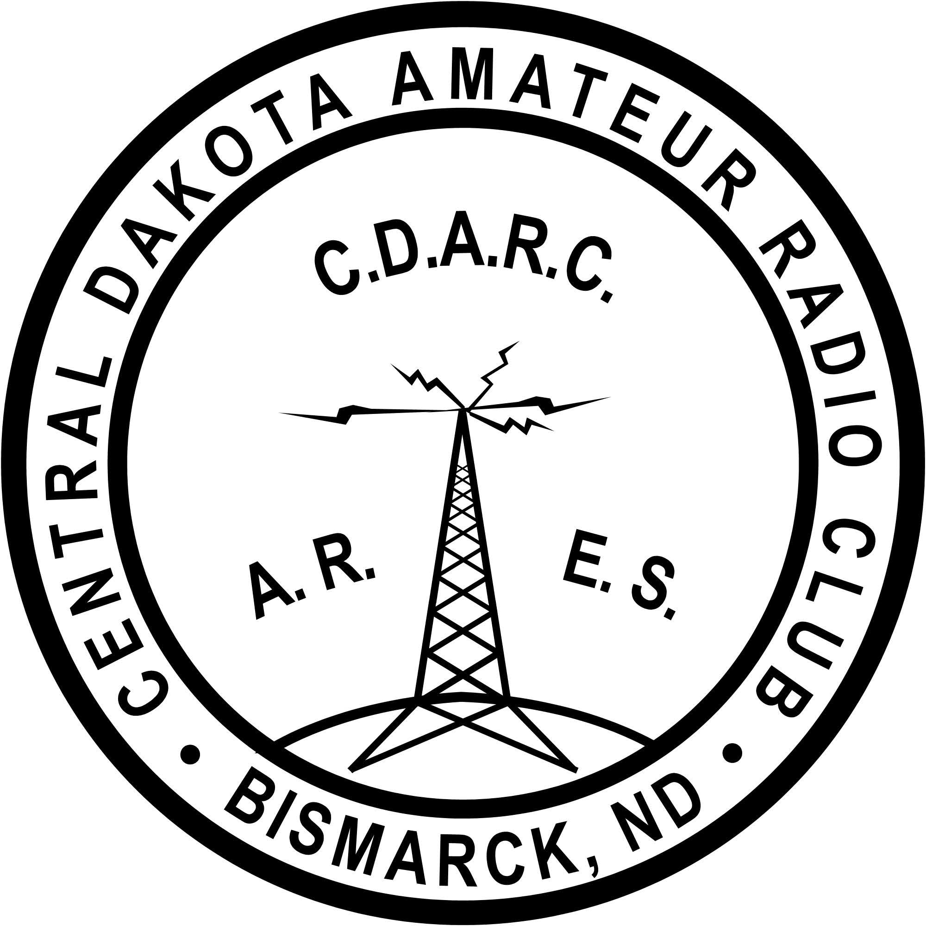

***Introduction***

The purpose of this procedure is to ensure a high-quality website and social media site.

***Proposing Changes to the Website or Social Media***

In order to ensure that the Central Dakota Amateur Radio Club (CDARC) website and social media remains consistent, any proposals for changing core design elements, overall site organization, or text must be sent to the Executive Committee. The decision to implement the proposed change will be up to the Executive Committee.

***Content Management and Server Access Guidelines for website***

All CDARC web pages are managed through the weebly.com website which can be accessed via the Internet. To ensure the security and integrity of the website, access will be granted to authorized Content Managers.

The responsibilities of the Social Medial master are:

1. to ensure updates are done in a timely manner
2. to ensure data on Facebook is accurate
3. to ensure updates are made to the calendar when needed
4. to ensure inquiries to the club are forwarded to the Executive Committee

***Mission Statement***

Central Dakota Amateur Radio Club - W0ZRT was established in 1971. Our purpose shall be to further the exchange of information and cooperation between members, to promote radio knowledge, fraternalism, individual radio operating efficiency, and to conduct programs and activities that advance the general interest and welfare of the United States, North Dakota, our community, and amateur radio

The responsibilities of the Webmaster are:

1. to ensure updates are done in a timely manner
2. to ensure data on website is accurate
3. to ensure a copy of the monthly noise letter is on the website when released
4. to ensure updates are made to the calendar when needed
5. to ensure domain name registration is current
6. to ensure inquiries to the club are forwarded to the Executive Committee

***Goals***

The responsibilities of the Executive Committee are to:

1. ensure the integrity of the club by providing current and accurate information on the website and social media

**Website and Social Media Standard Operating Procedures of Central Dakota Amateur Radio Club**

Central Dakota Amateur Radio Club

1

**Hosting**: The website of CDARCND.COM is hosted at weebly.com

[www.weebly.com](http://www.weebly.com)

<https://www.weebly.com/app/help/us/en>

This company handles all hosting and email related questions.

Passwords: Password for the domain and hosting accounts are stored in the president’s brief case on an usb drive and on the file “CDARC Website Information.doc”. This is a password-protected document. The President keeps the password.

This company may be contacted for domain login/passwords, DNS/Nameserver changes, and general domain support questions.

Content Managers will be responsible for adding and editing web pages on the site. This access should not be shared with anyone. Content Managers must ensure that web pages meet all criteria outlined in this document.

Authorization for Content Managers to access the website must be requested by contacting the Executive Committee. If a Content Manager must transfer access to another person, the Executive Committee should be notified before access is granted.

***Content Authors***

Content Author should regularly review the web pages under their jurisdiction to ensure that they adhere to the Standard Operating Procedures.

***Website Information***

*The following information is current as of 10/4/2019*

To access site, go to weebly.com/login.

Enter username and password.

To edit site, click on Edit Site on upper right of display.

**Domain name**: Currently the domain name CDARCND.com was secured from

GoDaddy.com**,** on 2/22/2015 and will expire on 2/22/2020. The Registrar can be contacted using the information below:

Central Dakota Amateur Radio Club

GoDaddy.com

<Type Phone Number>

<Type Email Address

2

**Email**:

**Currently there all CDARC accounts are setup using the email account of cdarcnd@gmail**.com, and the password currently is on president usb drive.

**Required Content**

Updated information that is relevant to the CDARC community.

Navigational links (i.e. navigation bar or menu).

All content should follow Priority One of the W3C web accessibility guidelines that meet Section 508 of the Federal Rehabilitation Act, which mandates electronic information and web pages be usable by persons with disabilities.

**Prohibited Content**

Advertising of any kind.

Content not related to Club Activities or interests.

Unapproved content promoting private businesses, enterprises or entities.

The use of inappropriate or offensive language is not permitted on our site. Inappropriate or offensive language includes, but is not limited to, any language or content that is vulgar, obscene, abusive, defamatory, harassing, hateful, profane, slanderous, lewd, pornographic, sexually suggestive, violent, or contains racially, ethnically, or otherwise objectionable content.

Do not post any content that violates any International laws or regulations.

Content which our organization considers to be inappropriate or offensive

will be edited or deleted at our discretion.

**Conditionally Required Content**

If copyrighted material is not owned by the Content Manager or Content

Author, permission for use of copyrighted material must be obtained.

If using the organization’s logo, use only the official logo and not a

variation.

**Strongly Suggested Content**

Current, updated information.

Links to educationally or professionally related web pages.

***Web Page Standards***

Good web sites have a clear and coherent message that is presented with an attractive layout. Text should be well written, graphic designs should be eye- catching yet simple, and web pages should be user-friendly, organized and fluid.

Four types of content apply to creating pages on the website:

Central Dakota Amateur Radio Club

3

Central Dakota Amateur Radio Club

**Font**

For consistency, use the following font standard and font size when adding new content to the website:

**Font Standard**: Arial is the default font for the website.

**Font Size**: The default font size is 14pt.

**Content**

Do not use underline to emphasize a word; instead use bold formatting. Underlined words are usually reserved for links and can be confusing to the reader when reading on the web.

Use bulleted-list and short paragraphs to break up large content – users tend to scan a page’s content.

One idea per paragraph - users will skip over any additional ideas if they

are not caught by the first few words in the paragraph.

**Graphics**

* Please design for the **maximum width of** <Check with Web Designer for maximum width in pixels>.
  + Images that require scrolling because they are larger than one screen are annoying and should be avoided.
  + The same is true with scrolling up and down to see an entire graphic.

***Dispute and Complaint Procedures***

Reviews of web pages may be conducted at any time by club members to ensure that the Website Standard Operating Procedures are properly implemented. Complaints of non-compliance with the Standard Operating Procedures may be reported to the Executive Committee via e-mail or to a board member. The complaint must include the reason or reasons for the complaint and specifically why the web page in question is in violation. Complaints that do not reference the specific items will not be addressed.

Complaints will be initially reviewed by the Executive Committee. If the complaint is determined to be valid, the President will contact the appropriate Content Manager or Content Author to discuss the complaint and explain the violation.

If the Content Manager or Content Author disputes the findings, the Executive Committee will schedule a meeting with the Content Manager or Content Author to discuss the violation(s).

***Web Page Conventions***

The following conventions should be used when creating or editing web pages.

4

•

5

Central Dakota Amateur Radio Club

CDARC reserves the right to review any web page receiving a complaint from a responsible party. If a web page is deemed in violation of the Standard Operating Procedures outlined in this document, the board reserves the right to delete the web page and take appropriate disciplinary or criminal action, if necessary.

***Disclaimer***

If you believe the content of any web page is offensive, obscene or inconsistent

with the Website Standard Operating Procedures, please express your concerns by e-mailing a member of the Executive Committee.

6